ADMIN Login : USER Login:

Username: admin Username: user

Password: admin Password: user

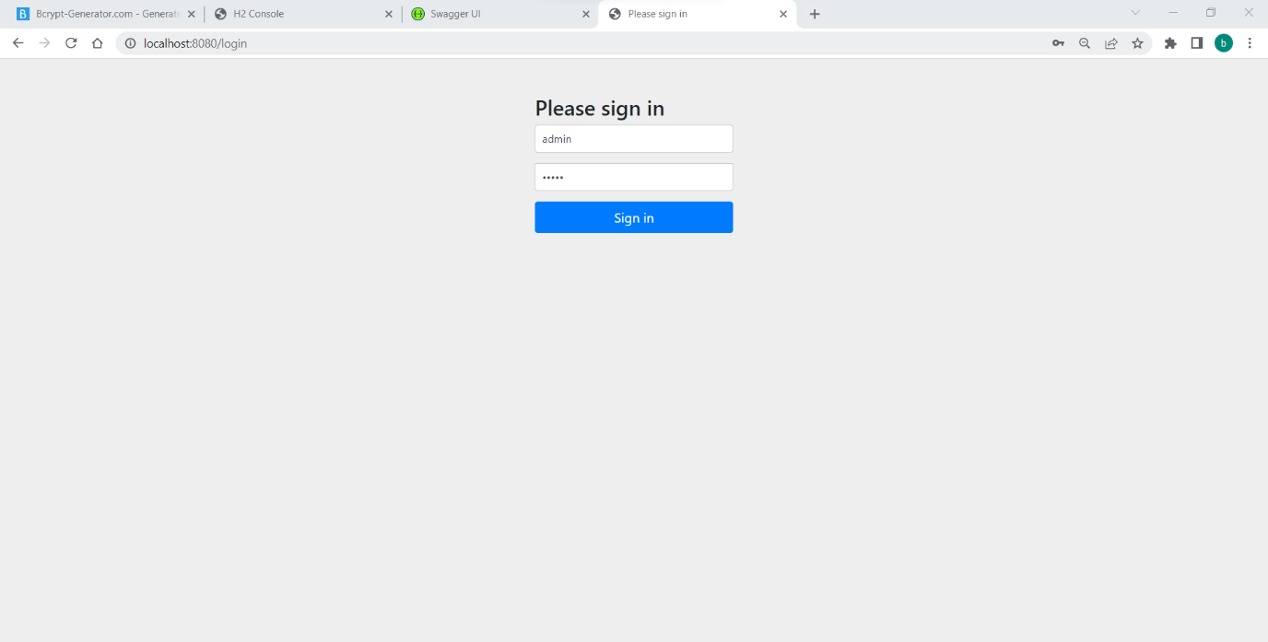

Welcome Page:



Adding Role dynamically in database where name specifies a role which can be assigned to a user that will be used for authentication purposes while interacting with the api.

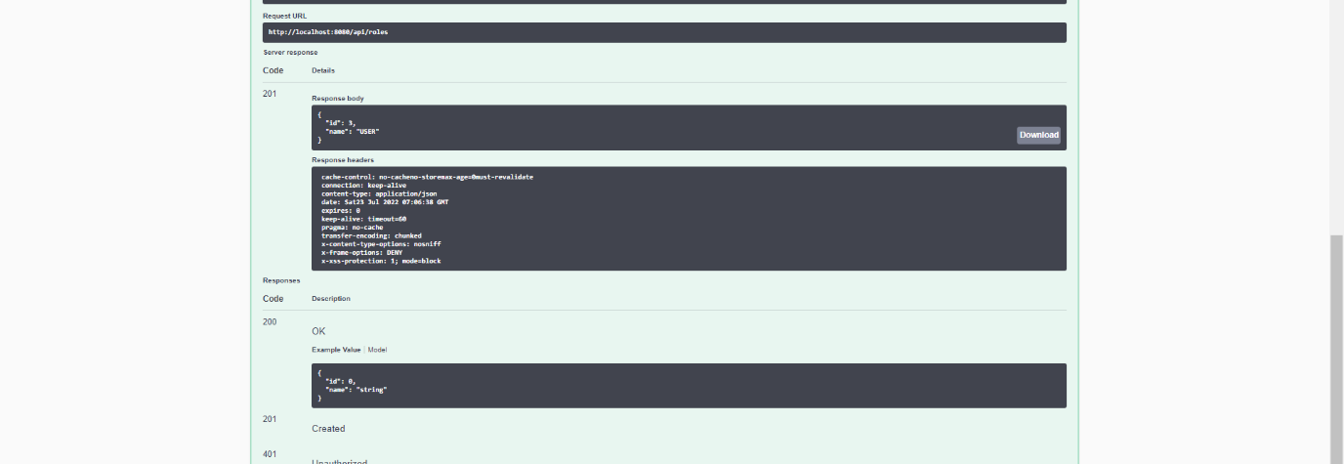

Adding User in database which can be used for authentication purpose

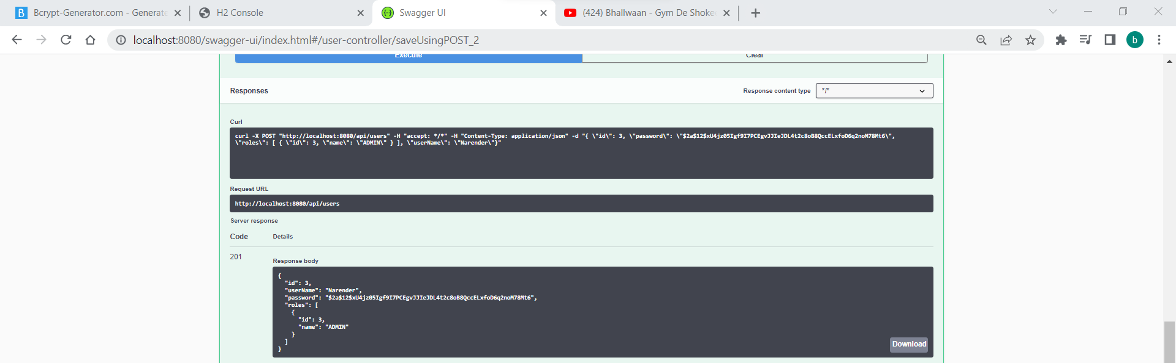

Getting Users in the database

Getting Role details from database

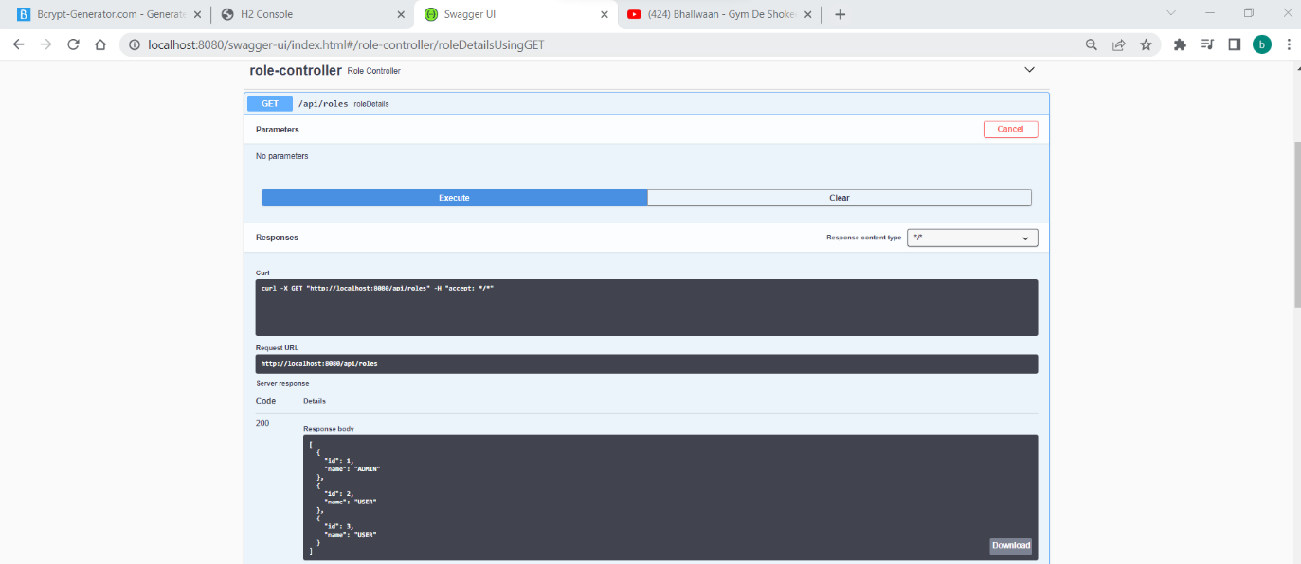

Adding employees in the database by Admin

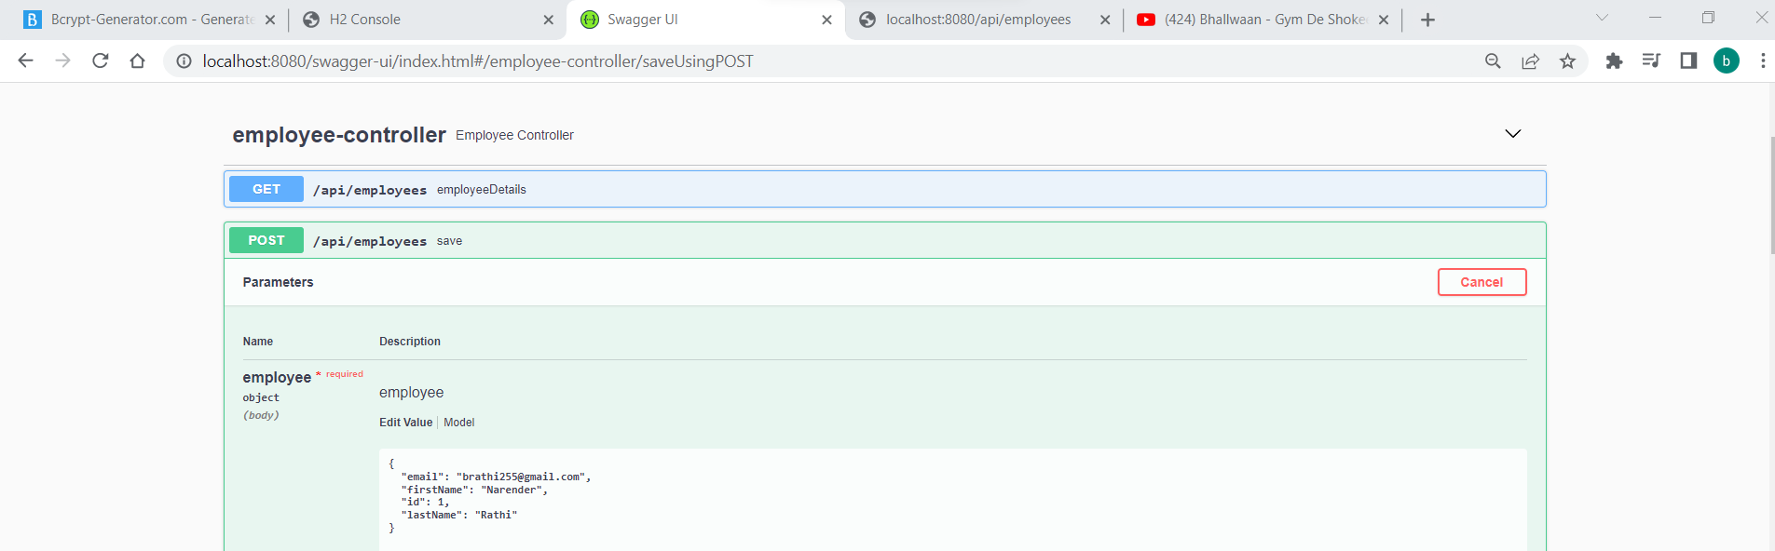

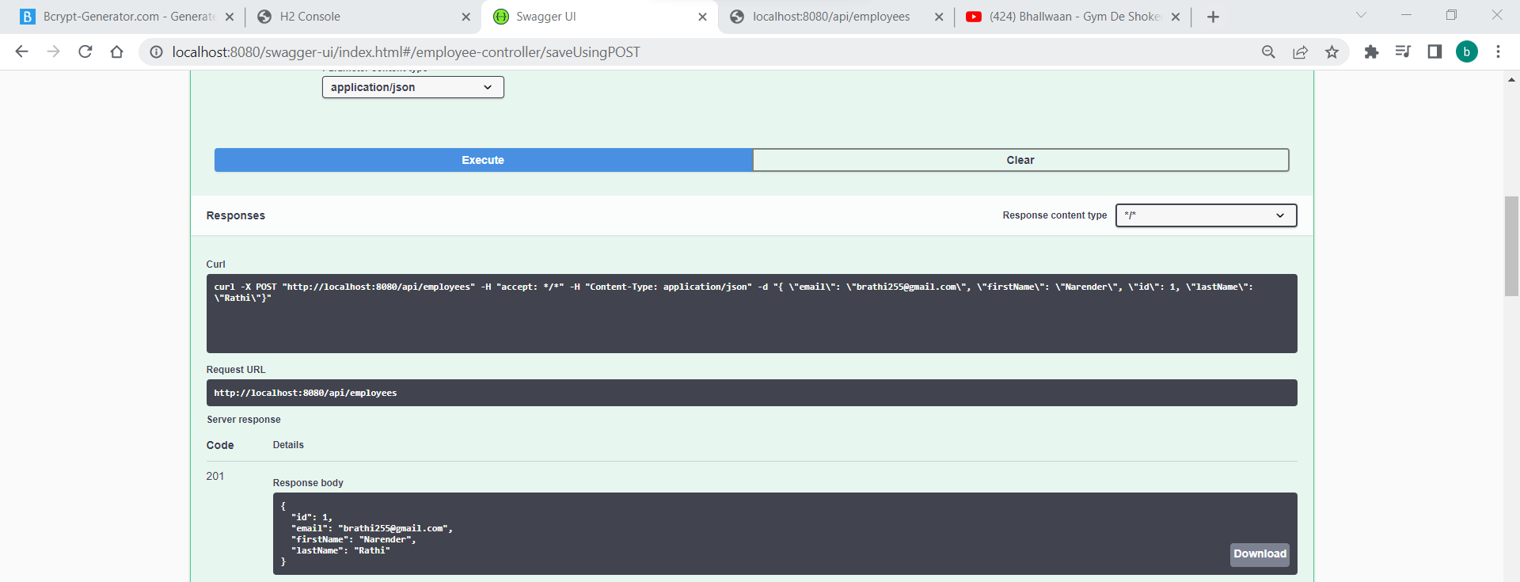

Added Employees in h2 console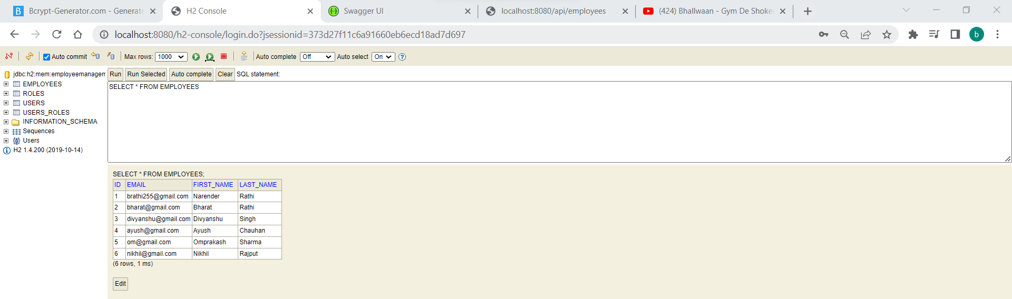

Getting employee by Id

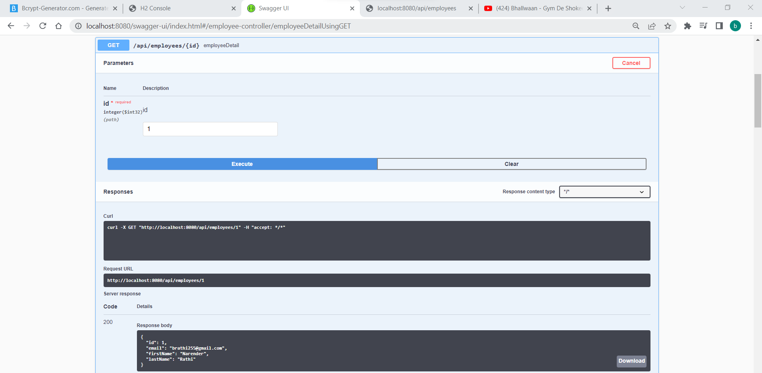

Getting employee by First Name

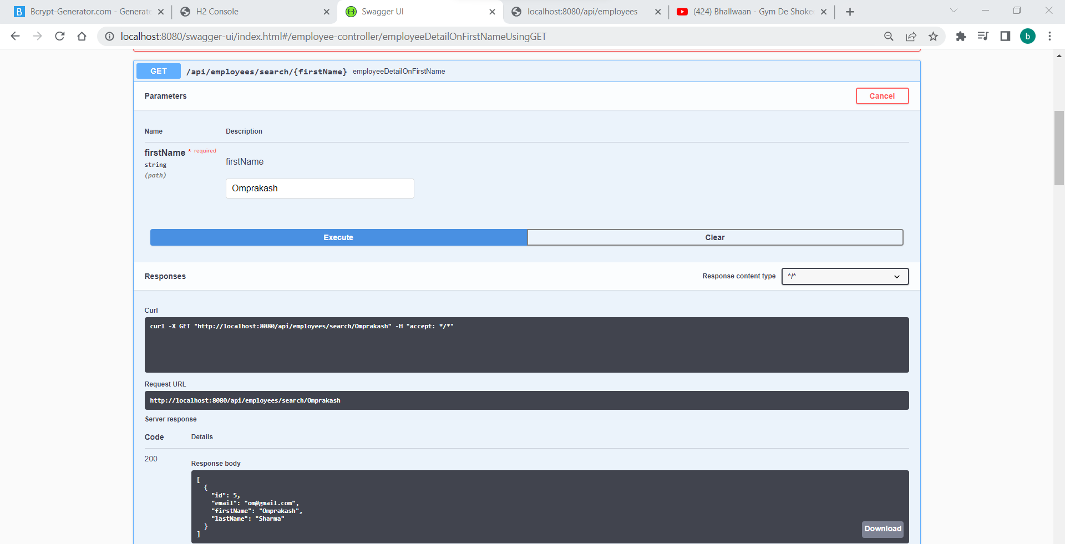

Getting employees details

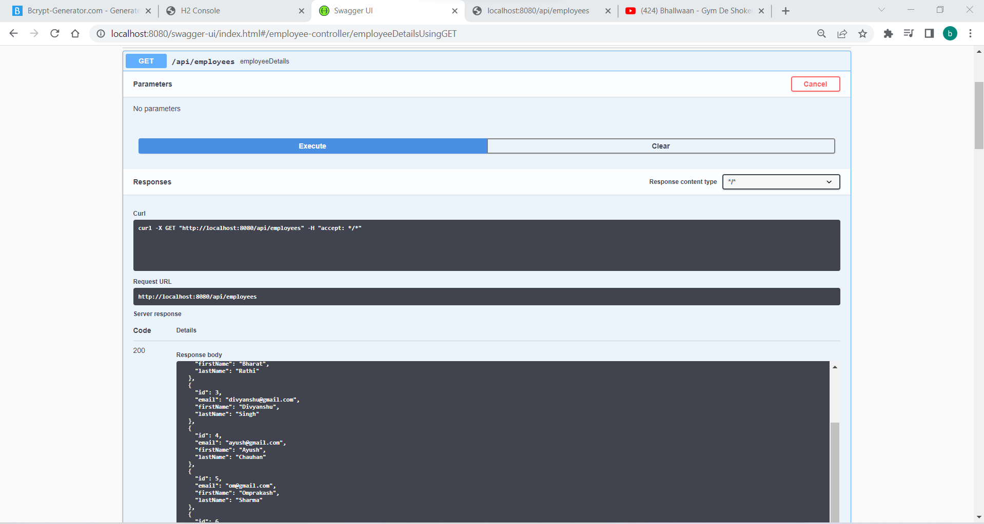

Updating employee

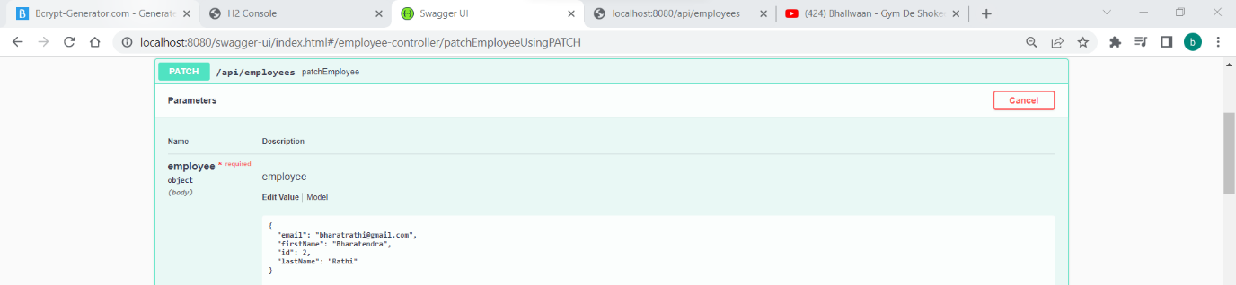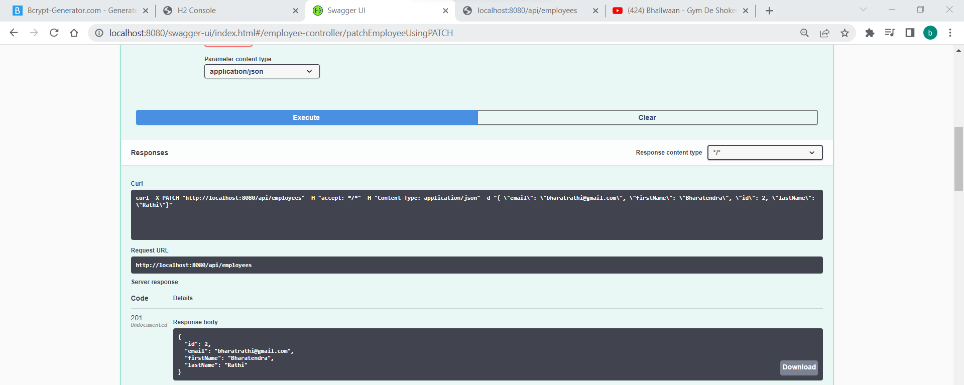

Updated employee shown in h2 console

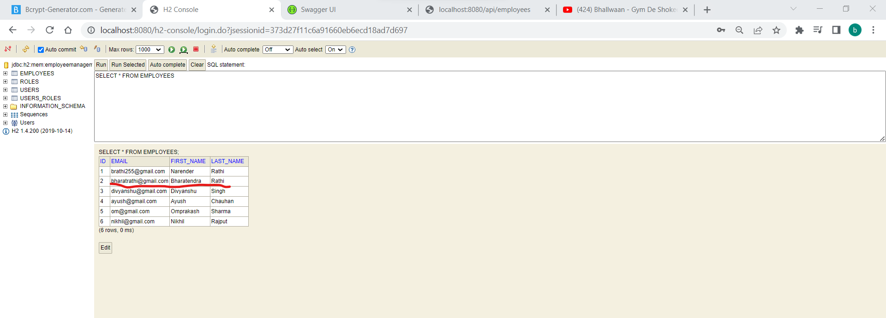

Deleting employee by Id from database

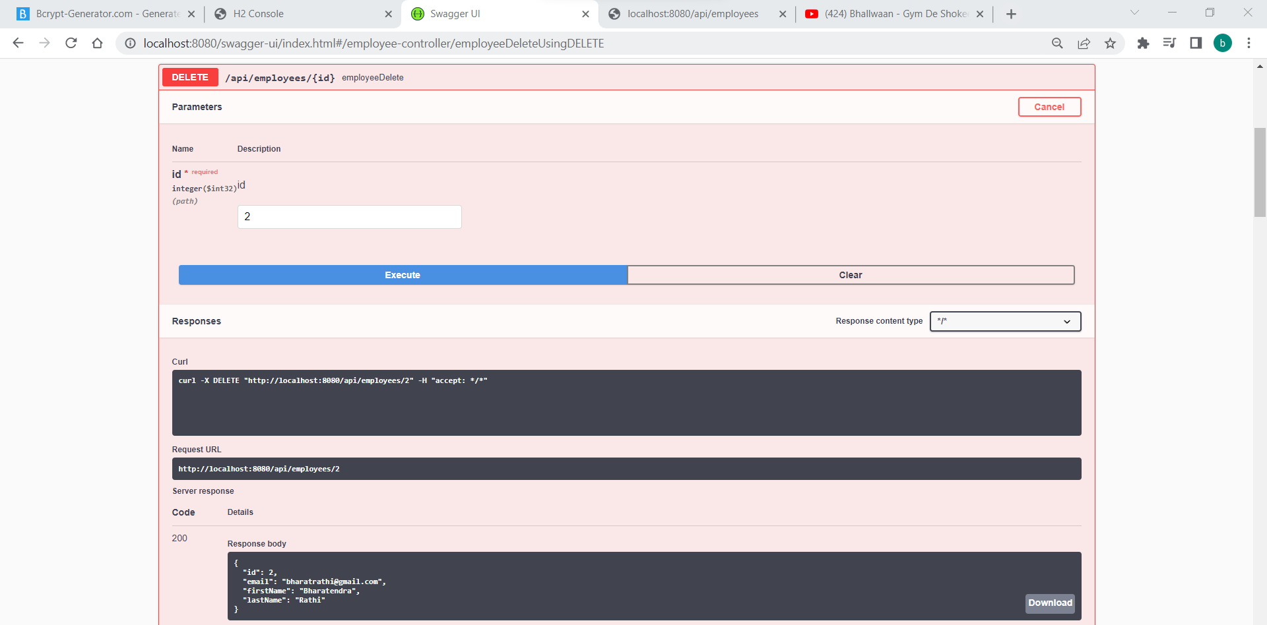

Sorting employees by their name in ascending or descending order

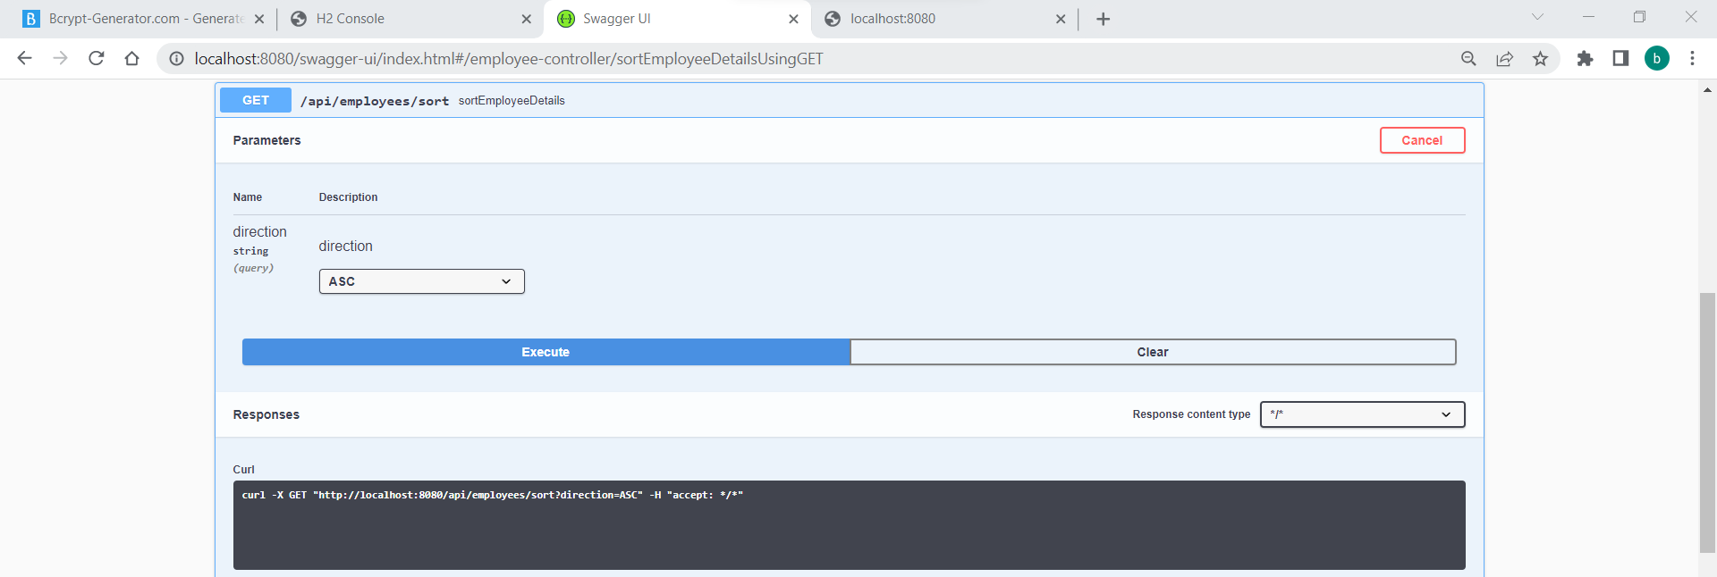

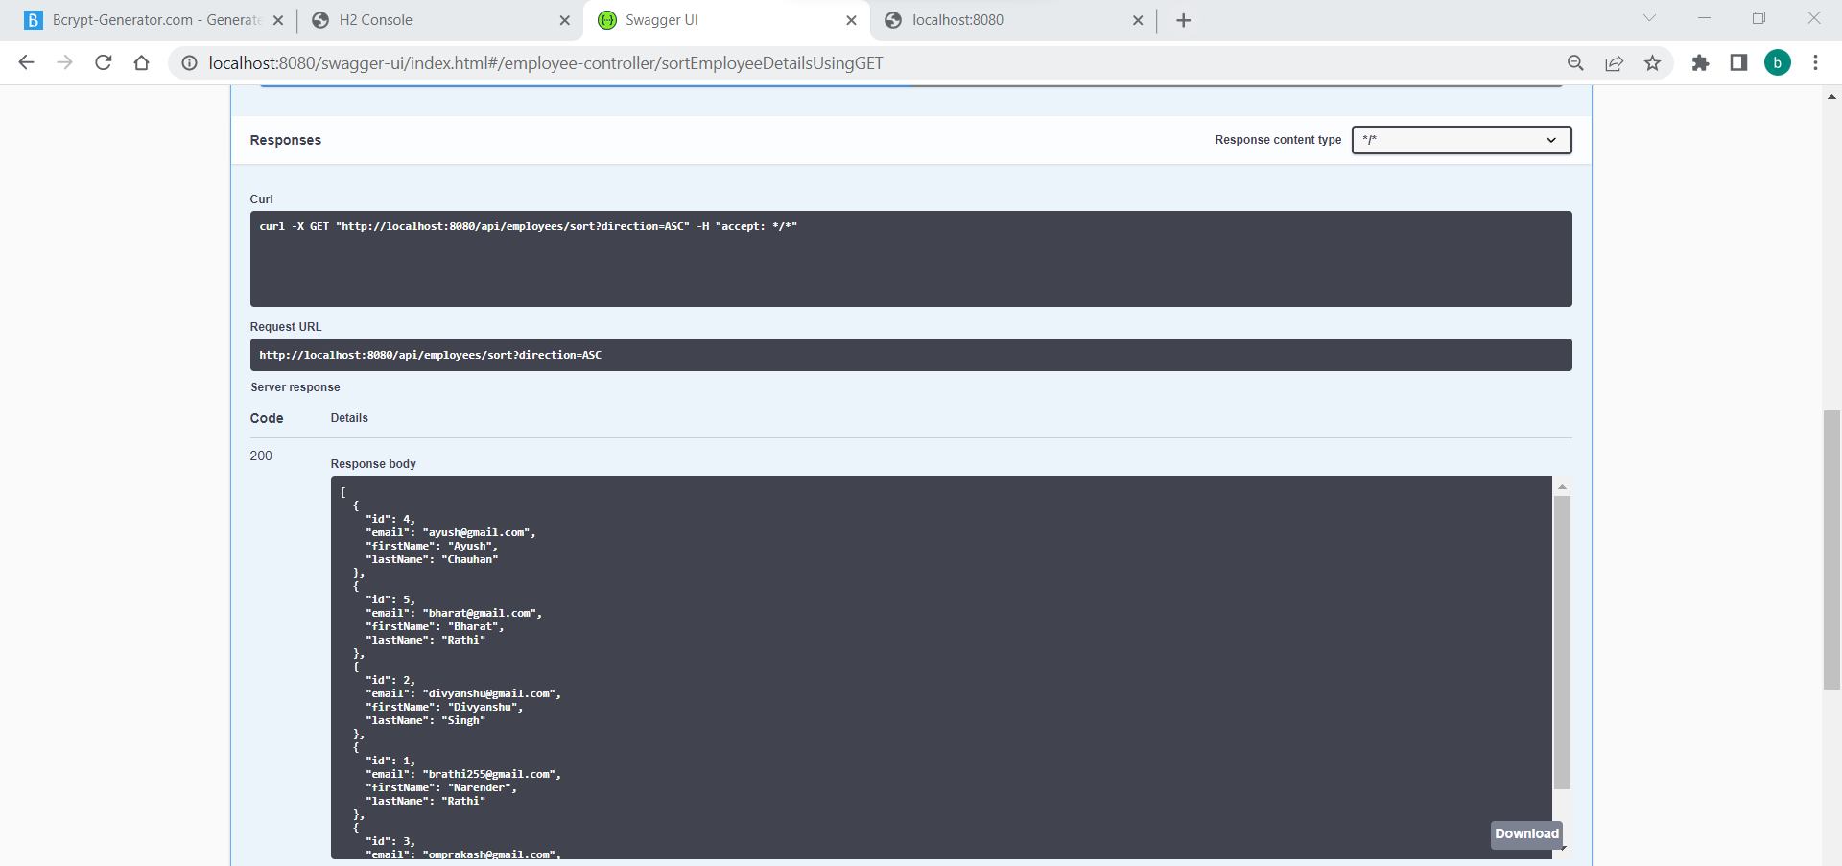

User Access Denied from adding employee in the database

